Implement programs for visualizing time series data
EX:No.2
DATE:01/02/25

AIM:
Write a program to implement time series data for import library, load data, Preprocessing and visualising.
ALGORITHM:
Step 1: Install required libraries (if not already installed).
Step 2: Import necessary libraries (pandas, numpy, matplotlib).
Step 3: Load air pollution data, parse dates, and set 'date' as the index.
Step 4: Remove duplicate timestamps and fill missing values.
Step 5: Select the 'pollution_today' column.
Step 6: Remove outliers using the IQR method.
Step 7: Ensure daily data frequency.
Step 8: Resample to weekly average (optional, not used in the plot).
Step 9: Create a figure and plot daily pollution levels as a line graph.
Step 10: Set labels, title, and legend for the plot.
Step 11: Show the plot.
CODE:

import numpy as np
import pandas as pd
import seaborn as sns
import matplotlib.pyplot as plt
df = pd.read_csv(r"C:\Users\HARISH\Downloads\archive\accident.csv", index_col=0, parse_dates=True)
df.index = pd.to_datetime(df.index, errors='coerce')
df.dropna(inplace=True)

df = df[~df.index.duplicated(keep='first')]
survival_col = next((col for col in df.columns if 'survived' in col.lower()), None)
if not survival_col:
raise KeyError(f"No 'Survived' column found. Available: {df.columns}")
print(f"Using column: {survival_col}")
total_cases = len(df)
survived_cases = df[survival_col].sum()
overall_survival_rate = (survived_cases / total_cases) * 100
print(f"Total Cases: {total_cases}")
print(f"Total Survivors: {survived_cases}")
print(f"Overall Survival Rate: {overall_survival_rate:.2f}%")
daily_survival_rate = df.groupby(df.index.date)[survival_col].mean() * 100
print("\nDaily Survival Rate:")
print(daily_survival_rate)
\df["Rolling_Mean"] = df[survival_col].rolling(window=7, min_periods=1).mean() * 100
print("\nRolling Mean Survival Rate (7-Day):")
print(df["Rolling_Mean"].tail())
survival_distribution = df[survival_col].value_counts(normalize=True) * 100
print("\nSurvival Probability Distribution:")
print(survival_distribution)
plt.figure(figsize=(12, 5))
sns.lineplot(x=df.index, y=df[survival_col] * 100, marker="o", color="b")
plt.title("Road Accident Survival Rate Over Time")
plt.xlabel("Date")
plt.ylabel("Survival Rate (%)")
plt.xticks(rotation=45)
plt.grid(True)
plt.show()
plt.figure(figsize=(12, 5))
sns.lineplot(x=df.index, y=df["Rolling_Mean"], color="g", label="7-Day Rolling Average")
sns.lineplot(x=df.index, y=df[survival_col] * 100, color="b", alpha=0.5, label="Original Data")
plt.title("Smoothed Survival Rate Trend")
plt.xlabel("Date")
plt.ylabel("Survival Rate (%)")

plt.legend()
plt.xticks(rotation=45)
plt.grid(True)
plt.show()
plt.figure(figsize=(12, 5))
sns.histplot(df[survival_col] * 100, bins=10, kde=True, color="purple")
plt.title("Survival Rate Distribution")
plt.xlabel("Survival Rate (%)")
plt.ylabel("Frequency")
plt.grid(True)
plt.show()
plt.figure(figsize=(8, 5))
sns.boxplot(y=df[survival_col] * 100, color="cyan")
plt.title("Box Plot of Survival Rates")
plt.ylabel("Survival Rate (%)")
plt.grid(True)
plt.show()
if 'Speed_of_Impact' in df.columns:
plt.figure(figsize=(10, 5))
sns.scatterplot(x=df['Speed_of_Impact'], y=df[survival_col] * 100, alpha=0.6, color="red")
plt.title("Survival Rate vs. Speed of Impact")
plt.xlabel("Speed of Impact (km/h)")
plt.ylabel("Survival Rate (%)")
plt.grid(True)
plt.show()
else:
print("Column 'Speed_of_Impact' not found, skipping scatter plot.")

OUTPUT:

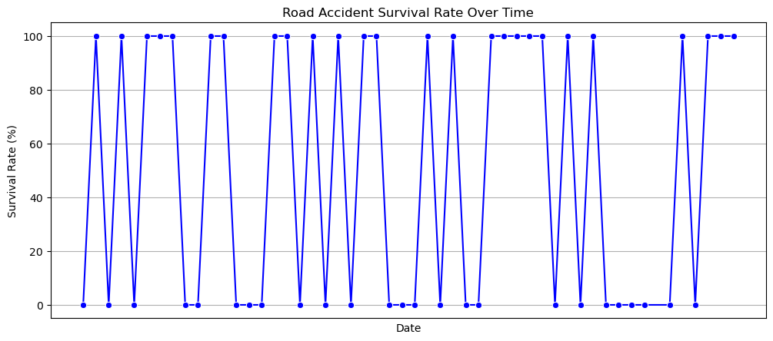

RESULT:
Thus, the program using the time series data implementation has been done successfully.

